Data Size 128 Bytes:  
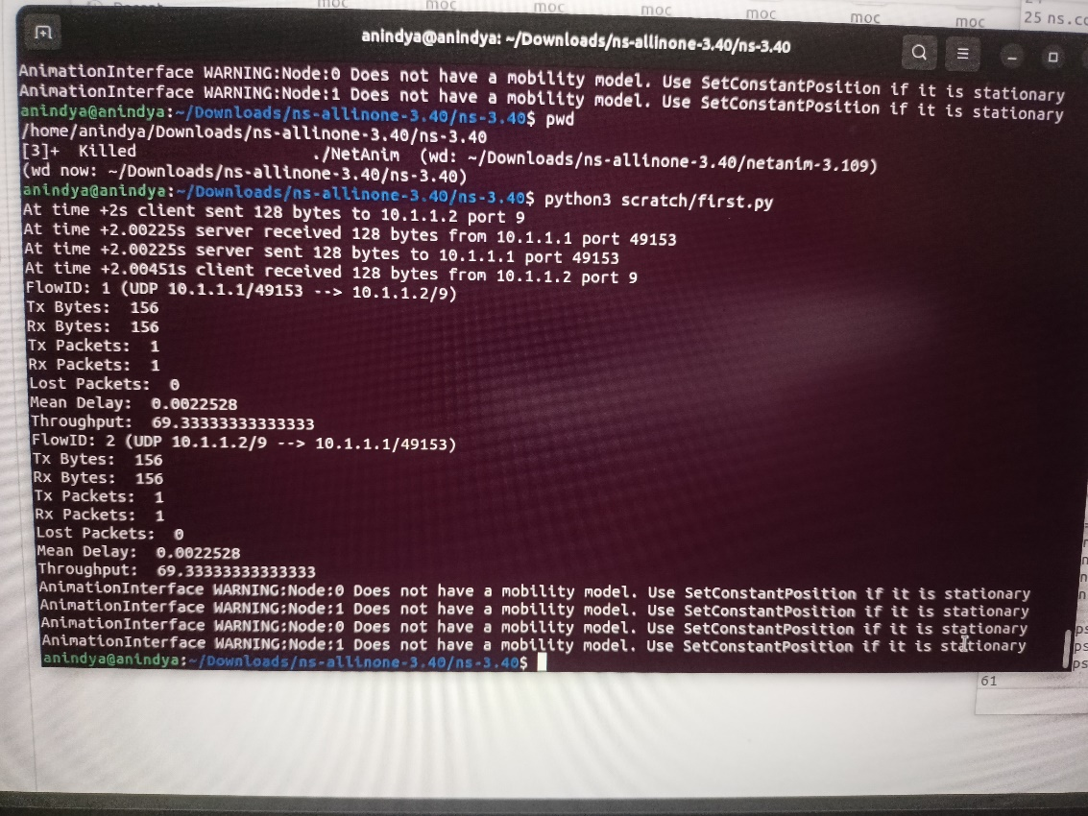

Data Size 256 Bytes:  
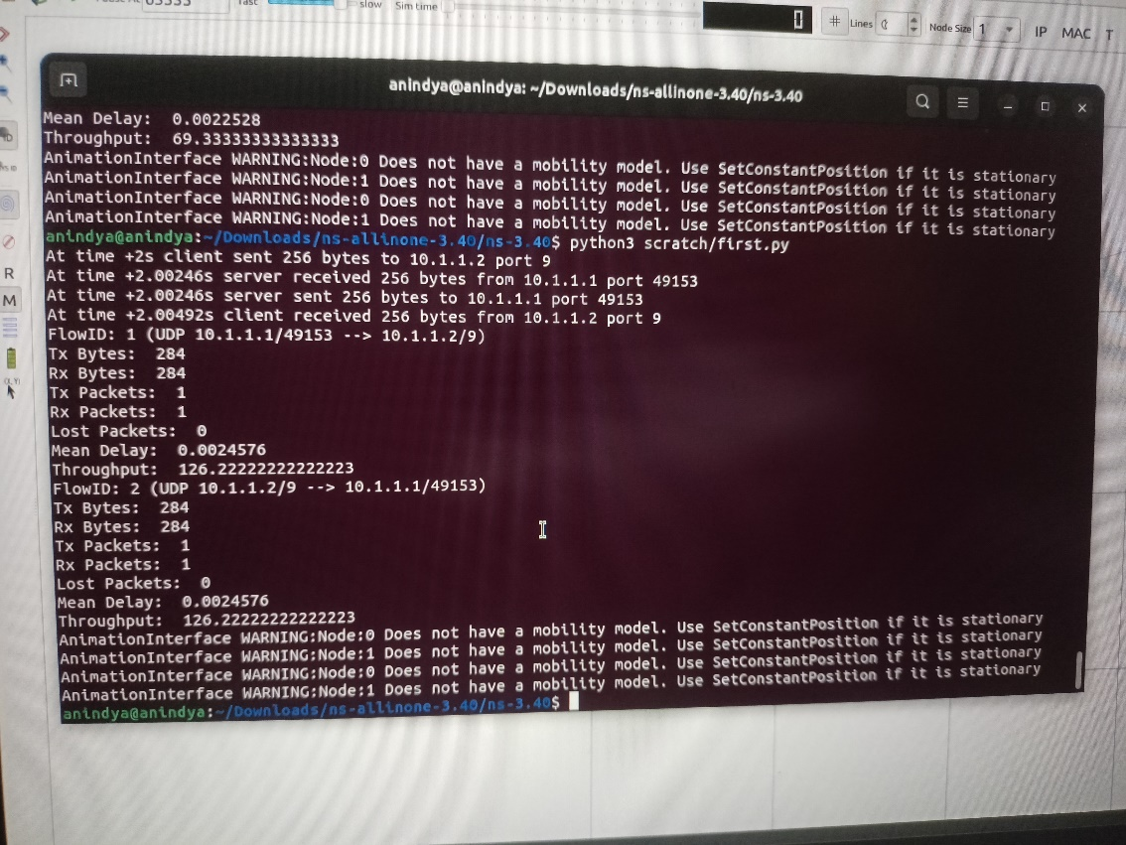

Data Size 512 Bytes:  
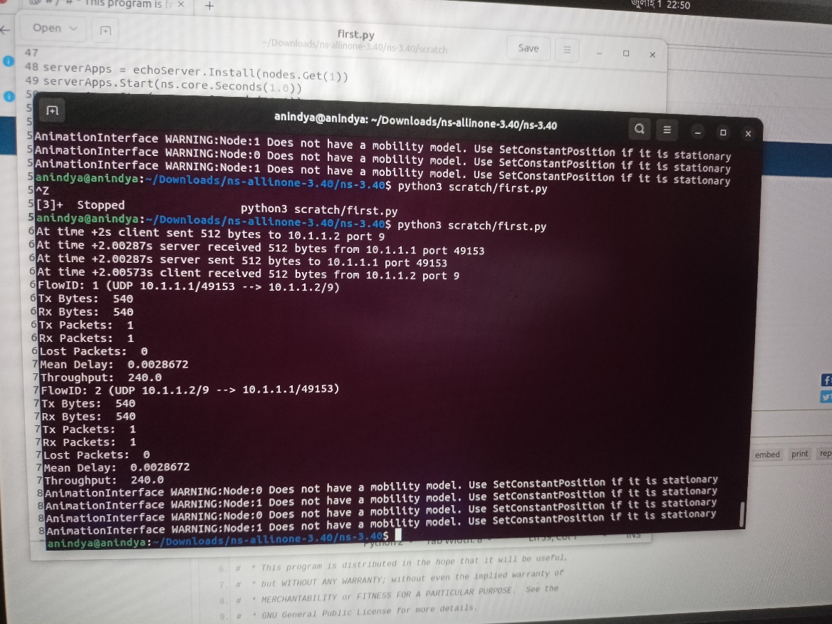

Data Size 1024 Bytes:  
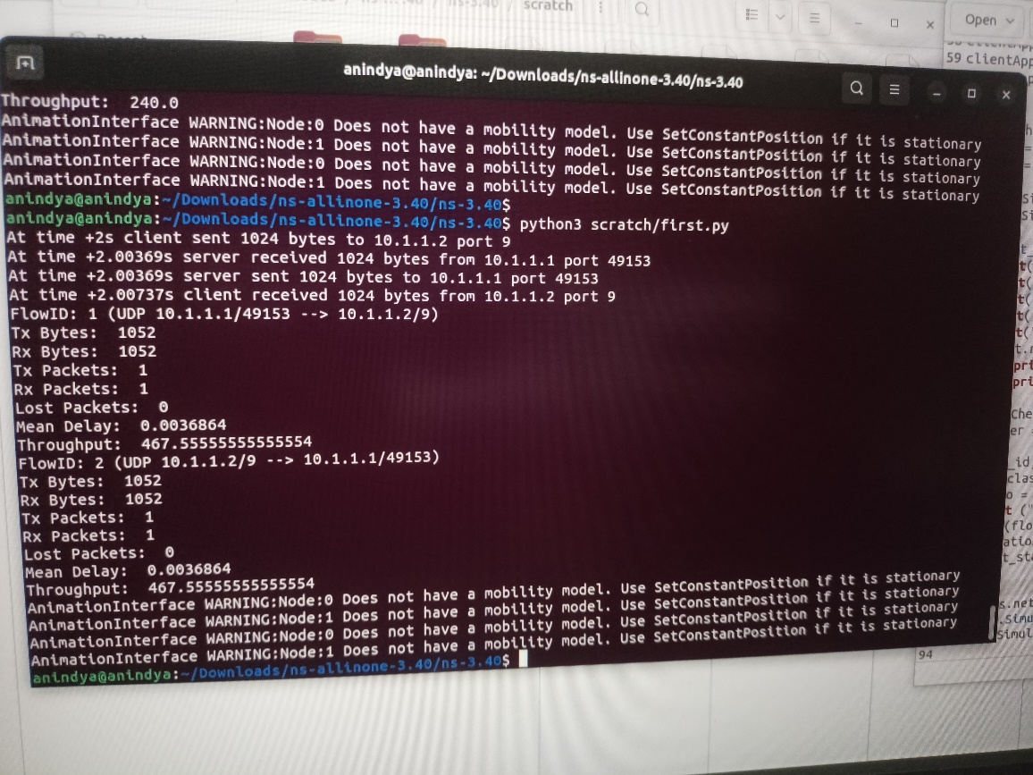

Data Size 2048 Bytes:  
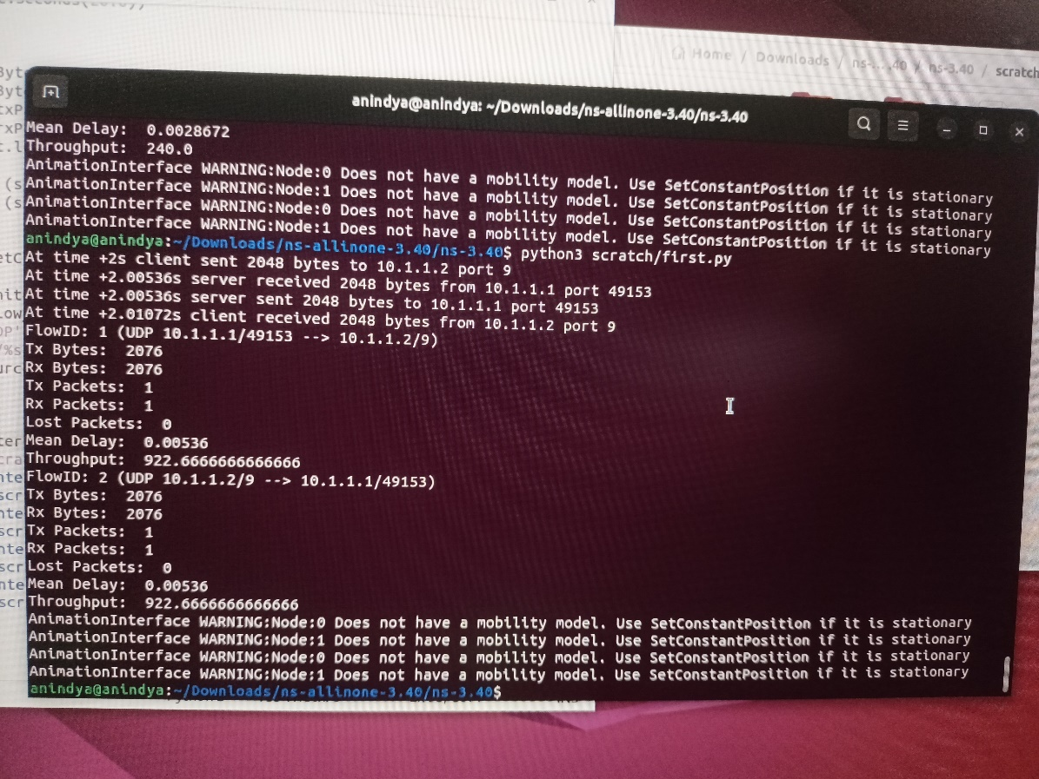

Throughput vs Data Size:

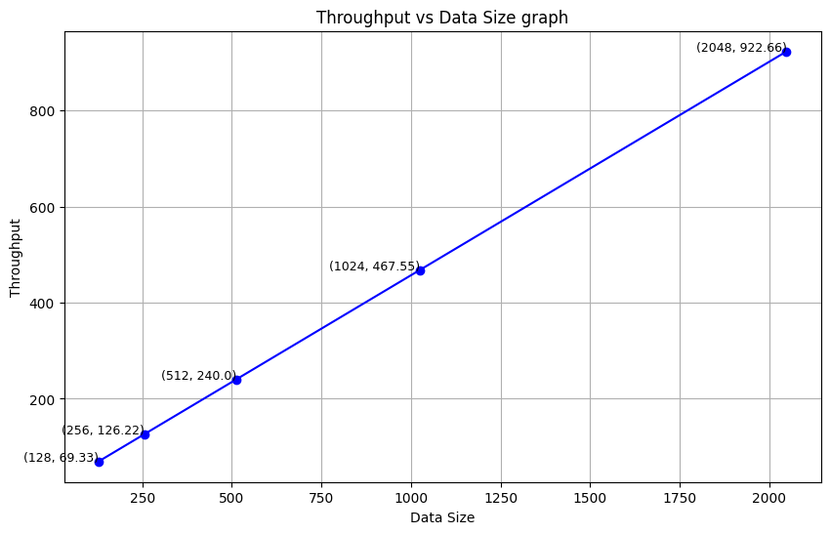

The graph shows that the relation between throughput and data size is linear.